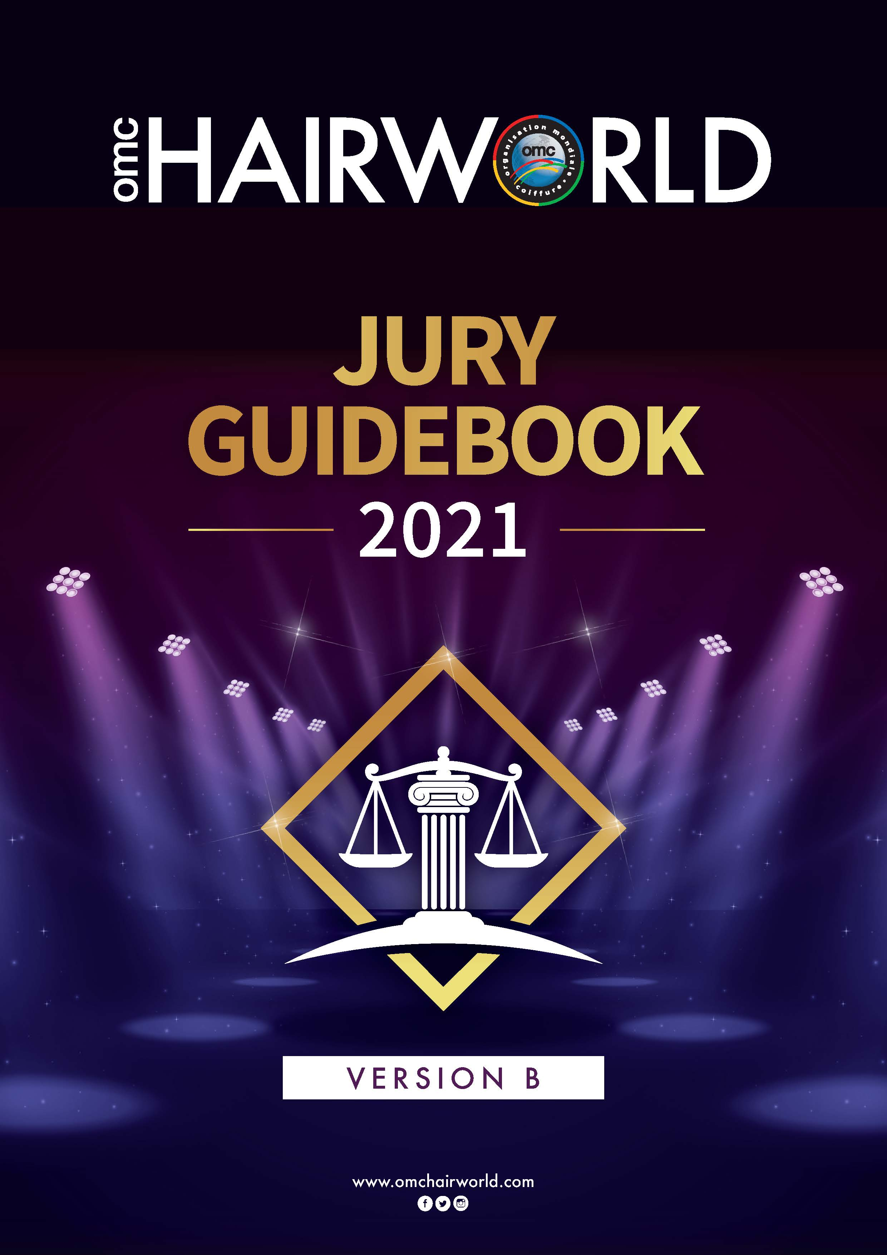

OMC JURY GUIDEBOOK VERSION “B”

Dear OMC Official Jurors,

This Jury Guidebook has been created to assist OMC’s jurors in maintaining the highest standard when judging OMC international competitions worldwide.

For fair judging results, OMC has set up a new jury grouping system. Only country jurors whose record is excellent with no red card in the previous championship will be selected to judge in OMC World Championships. OMC will determine which tests they will be judging.

A Jury Briefing takes place the day before each World Championship. OMC will inform the jurors in advance of the date and place were to meet.

Jury members can represent their national organization. The jurors can only judge in the sections were they have taken their examination. Hair Ladies, Hair Gents, Aesthetics or Nails Section).

All OMC jurors and trainers can be selected by OMC to present demonstrations for country organizations within the OMC Look & Learn educational program.

OMC asks all official jurors to carefully read this Jury Guidebook.

Sincerely,

OMC Board and Competition Directors

SUMMARY

Page

OMC Championship Program 4
OMC Professional and Supranational Jurors 5
Competition Directors Position………………………………………………………………………….6
OMC Scoring System Example 7
Attribution of Red Cards 8
Selection of Winning Hairstyles (10 or more competitors) 9
Jury Scores Guide 10
Penalty Points Chart Gents Seniors and Juniors 11
Penalty Points Chart Ladies Seniors and Juniors 12
Penalty Points Chart Ladies Aesthetics 13
Suspension / Disqualification / Penalty Rules 14
Equal Results 15
Best Juror Award 16
President Letter “Online Registration”…………………………………………………………………17

2021 OMC WORLD CHAMPIONSHIP JAPAN

Onsite Team & Individual Categories

OMC Automatic Team Selection

Senior Ladies Hair Section

Creative Cup Fashion Cup MH Prestige Cup LM
- Creative Style 1) Comm. Day 1) Fashion Gala
- Hair by Night 2) Comm. Evening 2) Fashion Bridal

Individual Trend Cup MH
Avant Garde MH 1) Commercial Cut
Fantasy Style MH 2) Fashion Pro Cut
Technical Free Style MH
40 + Master Stylist

ONLINE PHOTOGRAPH PORTRAIT
Aesthetics Section Nail Section:
Commercial Makeup LM Nail Painting -Box
Creative Makeup LM Nail Fantasy M-Hand
Eyebrow Shaping LM Nail Creative Bridal - LM
Smoky Eye Makeup LM Nail Fantasy - LM
Creative Neon Makeup LM
Stage Makeup LM
Body Painting LM
Student Eyebrow Tattoo MH

Senior Gents Section

Creative Cup MH Individual Trend Cup MH
  - Creative Style Hair Replacement 1) Commercial Cut
  - Classic Cut 40 + Master Stylist 2) Curly – Style

Barber Fades Cup LM Gents Fashion Pro Cup MH
- Classic Fade Cut 1) Fashion Pro Cut
- Skin Fade Cut 2) Tech.-Fashion Style

OMC RISING STAR AWARD

Jr. Section Individual tests
Jr. Gents MH Jr. Ladies MH
Creative Style Creative Style
Classic Cut Hair by Night
Skin Fade Cut Commercial Day
Commercial Cut Commercial Evening
Curly-Comm. Style

OMC Professional and Supranational Jurors

- Juror Qualification
All OMC jurors must hold an OMC Juror Certification, which will be obtained by passing the compulsory juror examination during an OMC World Jury Seminar.

- Professional Jurors are appointed by OMC World

OMC Competition Directors are considered professional jurors representing OMC World. OMC will add 3 OMC professional juror teams to each of the concerned tests. Their scores will be divided by 2 and become two individual score cards. This concept will add additional fairness to the OMC judging system.

OMC Supranational Jurors

Each member country organization will be asked to send a maximum of 2 jurors for each of the Ladies and Gents Section, plus 1 Aesthetic juror and 1 Nails juror. None of these jurors must have received a red card in their latest competition.

Regarding countries that have multiple organizations, OMC will decide which jurors will judge in the concerned tests, representing their countries.

Juror Grouping

The jury groups will be composed of a minimum of 5 and a maximum of 9 jurors, including the 2 OMC professional jurors.

- Fair Judging
To establish fair judging, the jurors, if at all possible, may not judge in tests where their own competitors are participating.

- New Jurors
The Competition Committee will decide if the scores of a new juror will count or not.

Jury Briefing

At the jury briefing the day before the championship, only selected jurors will receive an envelope showing which tests they will be judging.

Jurors dress code

In order to establish a unifying dress code, it is essential that all Gents jurors wear black attire. The attire can be trendy or classic. Shirts and scarfs can be of any colour. The Ladies jurors’ dress code is white and blue or white and black with other accent colours.

Juror Disqualification

Juror disqualification is 1 year or more, depending on the infraction committed.

COMPETITION DIRECTORS POSITION

The Competition Directors in both the Ladies and Gent's in Hair, Aesthetics, and Nail Section is composed of knowledgeable OMC member countries organizations whose members are invited by the OMC World President to be part of the competition directors commission of the concerned year.

The OMC President will send an Invitation letter 3 months before the OMC world championship of the concerned year. Those knowledge hairstylists who are eager and proud to assist in directing the OMC championships. Their position is on a voluntary basis and they are responsible to pay their own travel and accommodation if they accept the invitation.

Functions of the Competition Directors

- Each competition directors will receive a job description by the OMC Competition Global Directors who ‘s under the authority of the OMC world President.

- The Competition Directors coordinate all competitors in the village holding area according to each of the concerned categories. Those competitors will be accompanying in the championship arena and direct them to their assigned mirrors numbers. The mirror number will be distributed to the competitors In the competitors village holding area.

- The Competition Directors responsibility is to report the infraction to the General Commissioner of the concerned category test. The competition Directors are not responsible to penalize any of the competitors.

- Before the competition starts, each General Commissioner who is assigned to the concerned category test, together with a Competition Director will check all model and competitors of their own section, if they have abided by the OMC rules. If any infraction is found, they will record the competitor's mirror number and the infraction that occurred on paper.

- The General Commissioner will discuss it with the OMC Competition Global Director and the OMC World President, together they will make the final decision to penalize the concerned competitors or not.

- It is advised that the competition Director to take a photo of the infraction, with the OMC photo camera. The photo is a sustainable proof of the infraction. If no photo of the infraction was made, no proof is available; therefore, the infraction cannot be implemented. (Except for the stop instruction).

- All decisions made by the OMC General Commissioner and Competition Global Director must be signed by both, The OMC Competition Global Director is responsible to take the sealed envelope of the concerned Jurors score cards to the computer staff. The computer programmers will enter the penalty points in the concerned competition tests.

- The Competition Global Director is responsible to brief the Jurors of the concerned tests, before they are called to Judge.
OMC Scoring System Example

Jurors' country scores, as well as red cards, are removed and replaced by the average of all other jurors, basing on the first rectification of the juror concerned.

Scores given by jurors
28 – 26 – 30 – 27 – 28 – 25 – 25

First rectification
Scores given by jurors to competitors of their own country are omitted (27 in this case)

Calculation of first average omitting score 27
28 + 26 + 30 + 28 + 25 + 25 = 162: 6 = 27

New average based on the remaining jurors' scores:
27 + 27 +27 + 27 + 27 +27 +27 = 189

Second rectification
Based on the competitor ranking calculated on first rectification scores, red cards are calculated. Scores given by jurors with red card are omitted (30 in this example)

Calculation of average omitting score 27 (national juror) and score with red card 30 (red card).
28 + 26 + 28 + 25 + 25 = 132: 5 = 26.4

Final score: 26.4 x 7 = 184.8

Calculation according to OMC Jury Guidebook

Juror 1 | Juror 2 | Juror 3 | Juror 4  National  Juror | Juror 5 | Juror 6 | Juror 7 | Total score  given by remaining jurors | Final Average
28 | 26 | 30 | 27 | 28 | 25 | 25 | 189
28 | 26 | 30 | Omitted  national juror | 28 | 25 | 25 | 162 | 162:6=27  Juror 3 gets a red card based on competitor classification
28 | 26 | Omitted  Red card | Omitted  national juror | 28 | 25 | 25 | 132 | 132:5=26.4
26.4 | 26.4 | 26.4 | 26.4 | 26.4 | 26.4 | 26.4 | 184.8 | 184.8

Attribution of Red Cards

The scores of country jurors and of jurors receiving red cards will be omitted. After recalculation, these jurors' cards will be replaced by the average score of all other jurors.

Individual red card
- If the scores 30, is found on the 8th place or lower 1 time in a test.
- If the score 29 is found on the 9th place or lower 1 time in a test.
- If the score 28 is found on the 10th place or lower 1 time in a test.

- If the score 27 is found on the 11th place or lower 1 time in a test.
- If the score 25 is found on the 1st place 1 time in a test.

Juror Disqualification
Jurors receiving 2 or more red cards in the same test will be disqualified for 1 year. If the juror receives 3 red cards or more in two different test that juror will be will be disqualified for 2 year.

Incompetence or unfair judging
In addition to the red cards given automatically by the computer, the Lenience Committee may disqualify jurors whose judging is found to be incompetent or unfair, even if they have not received any red cards.

Lenience Committee
A Lenience Committee will analyze the scores given by jurors who received 2 or more red cards. The OMC Lenience Committee can remove red cards accordingly to their final objective analysis.

Selection of the winning hairstyles (10 or more competitors)

To ensure fairness in all OMC competitions, jurors must be clear, unbiased, systematic and efficient. In order to accomplish these tasks in a relatively short time, below are the recommended judging guidelines and criteria.

The OMC scoring system allows to focus only on the top scores indicated in the boxes. Follow the steps below.

- First walk-through: The jurors look at the general work of all competitors without assessing any scores, but taking notes with the plus + and minus – signs.

- Second walk-through: Start selecting the top 3 winners, following with the 4th and 5th place.

- Select the top 3 scores: The scores 30, 29, 28 must be given only 1 time.

- Score 27: The score 27 can be given a maximum of 2 times (check the score chart).

- Score 26: The score 26 can be given a maximum of 7 times (check the score chart).

- Score 25: The score 25 not being included in the box, it is no longer needed to be assessed. All competitors automatically receive the score 25.

By following the above steps, you have completed your professional task and may qualify to be awarded the OMC's Best Juror Award if you have reached 114 points in 1 test.

A juror who receives a red card in a championship does not qualify for receiving the Best Juror Award in that championship, even if he/she has reached the 114 points.

Jury Scores Guide

1 to 10 competitors
30, 29, 28 = 1 time
27 = 1time
26 =
25 = Score automatically awarded

11 to 20 competitors
30, 29, 28 = 1 time
27 = 1 time
26 = maximum 3 times
25 = Score automatically awarded

21 to 30
30, 29, 28 = 1 time
27 = 1 times
26 = maximum 4 times
25 = Score automatically awarded

31 to 40
30, 29, 28 = 1 time
27 = maximum 2 times
26 = maximum 5 times
25 = Score automatically awarded

41+
30, 29, 28 = 1 time
27 = maximum 2 times
26 = maximum 7 times
25 = Score automatically awarded

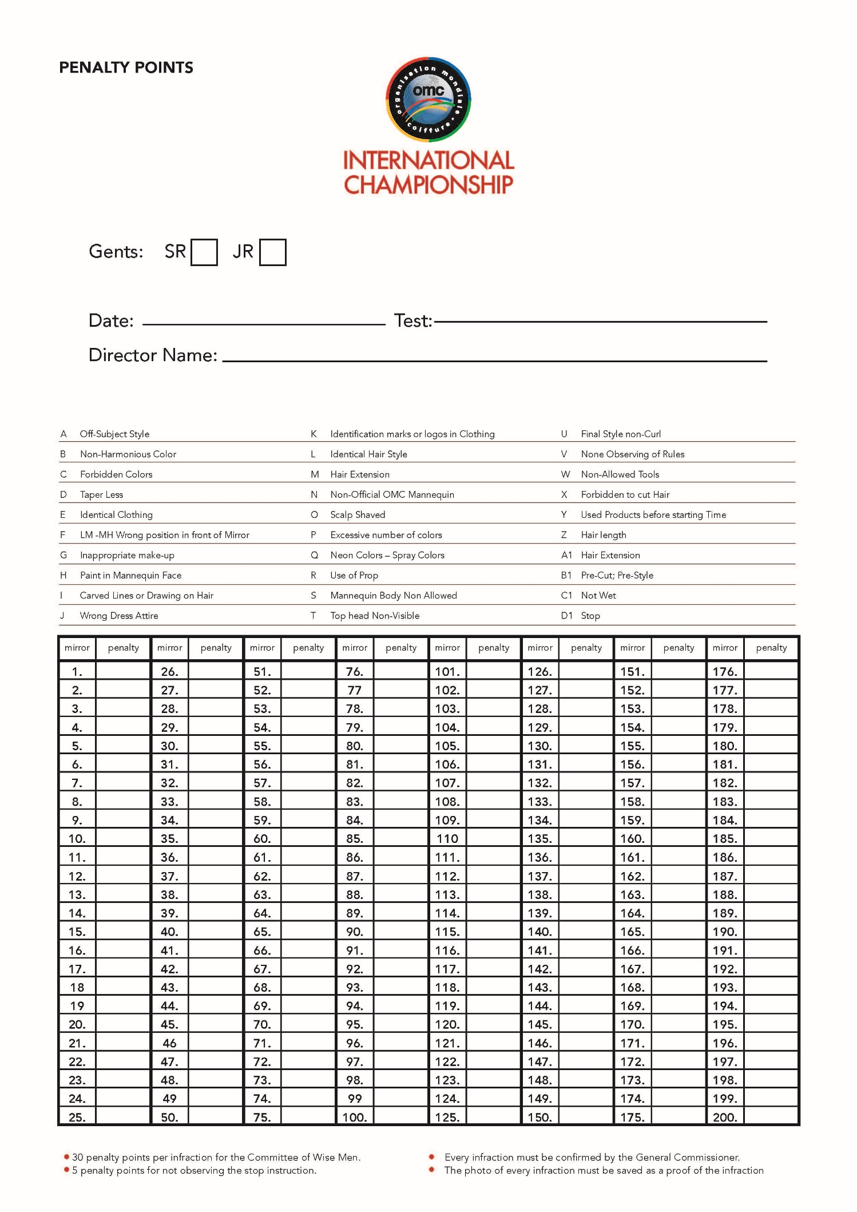
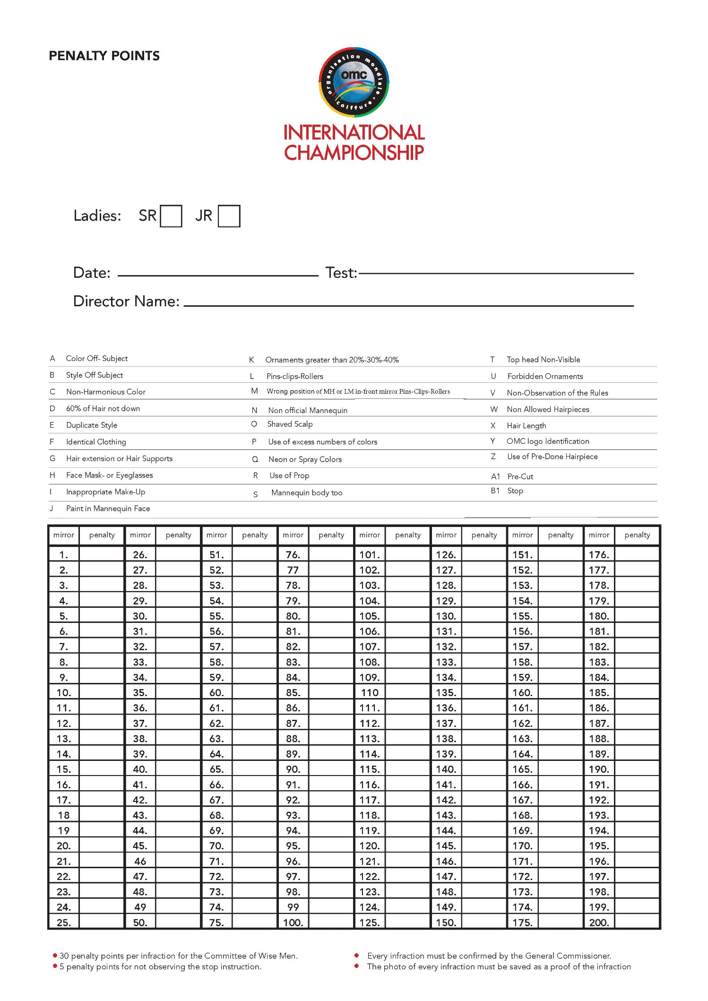
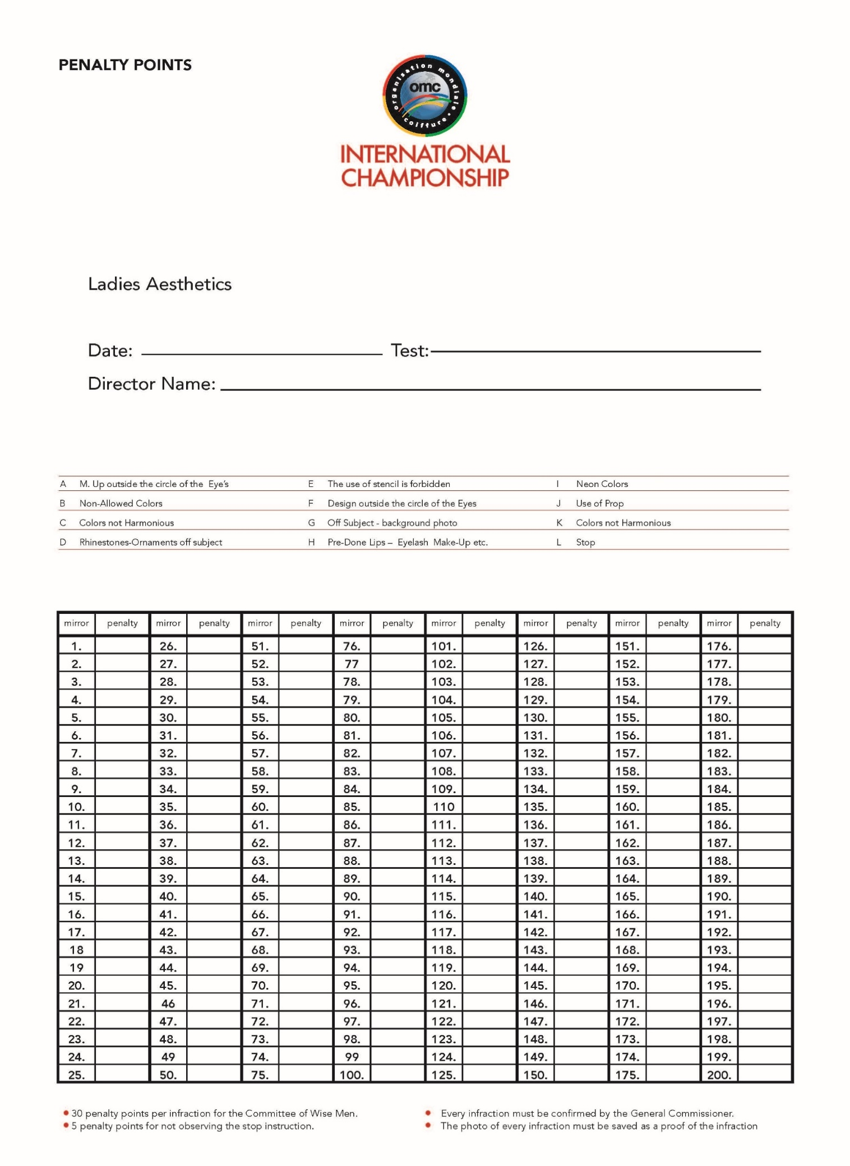

Suspension / Disqualification / Penalty Rules – Re: Red card page

- General rules to be observed
- If a juror arrives late at the Jury Room, the Competition Global Director or the General Commissioner will decide if he/she will be admitted in the Jury Room and to judge the test.
- Jurors are not allowed to leave the Jury Room while waiting to judge, except for going to the restroom.
- Once a juror has turned in his scorecard, he must leave the Championship Arena and directly go back to the Jury Room if he/she is selected to judge other tests.
- Jurors who, once they are finished judging, are found to be circulating in the competition arena will have their scores omitted and will not be allowed to continue judging in that championship.

2. Immediate disqualification of jurors
- Jurors directing other jurors to see a particular mirror number.
- Jurors talking to each other on the competition floor.
- Jurors using mobile phones in the Jury Room or on the Competition Floor.
- Jurors taking pictures while judging on the Competition Floor.

3. Voiding of Scorecards
If a juror shows inexperience during a competition (skipping a score, illegible scorecard, not completing judging in time), the General Commissioner may disregard his/her scorecard at any time.

4. Consequences of red card attribution
The official notification concerning the red cards will be sent to the jurors’ organizations and to the jurors concerned.

5. Disqualification Re: red card page

Equal Results

Individual tests

- The President of the Jury is appointed by OMC according to best judging record.

- In case of equal scores, the scores of the Jury President determine the first place in each test (Ladies and Gents).

- In case the tie is not broken, the computer will continue using the sequence of the jury list down to the last juror.

General Classification in combination or team competitions

If two teams have equal scores, ties will be broken by comparing the scores of the competitors of each team, combination or individual, starting from top downward. The advantage will be given to the competitors/teams that have the higher scores in the following tests:

- Ladies' Hair by Night

- Ladies' Commercial Evening MH

- Ladies' Fashion Pro MH

- Ladies Bridal

- Gents Commercial Cut

- Gents Classic Cut

- Gents Fashion Pro

- Gents Barber Classic Fade

Best Juror Award - only for jurors who are judging the seniors tests.

The Best Juror Award will be presented every year to the jurors who have obtained the highest points in a test.

The number of competitors must be 10 or more in a test. A juror receiving a red card does not qualify for the Best Juror Award.

Judging Example - Evaluation

The evaluation is made by adding up the top four (4) competitors' scores of each test. Only jurors reaching 114 points in a test will receive the “Best Juror Award“.

Juror no. | 1 | 2 | 3 | 4 | 5 | 6 | 7
 | 30 | 29 | 28 | 29 | 27 | 27 | 25
 | 29 | 30 | 29 | 27 | 28 | 26 | 26
 | 28 | 28 | 30 | 28 | 29 | 28 | 27
 | 27 | 27 | 27 | 30 | 30 | 29 | 30
Totals | 114 | 114 | 114 | 114 | 114 | 110 | 108

